Addition with base 10 blocks (tens andones)
Draw blocks to solve the addition questions.

Example: 23 + 34 =  + | = | = | 5Tens =57  7units
a) 14 + 31 = |  | = | Tens=  units
b) 42 + 16 = |  | = | Tens=  units
c) 33 + 34 = |  | = | Tens=  units
d) 10 + 26 = |  | = | Tens=  units

Addition with base 10 blocks (tens andones)
Grade 1 Base Ten Blocks Worksheet
Draw blocks to solve the addition questions.

Example: 23 + 34 =  + | = | = | 5Tens =57  7units
a) 32 + 51 = |  | = | Tens=  units
b) 17 + 20 = |  | = | Tens=  units
c) 63 + 11 = |  | = | Tens=  units
d) 10 + 40 = |  | = | Tens=  units

Addition with base 10 blocks (tens and ones)

Draw blocks to solve the addition questions.

Example: 23 + 34 =
 |  |  | 5 Tens
+ | = | = | 7 Ones ⁼⁵⁷
a) 15 + 14 =
 |  | = |  | _{Ones}^{Tens} = __
b) 22 + 33 =
 |  | = |  | _{Ones}^{Tens} = __
c) 54 + 31 =
 |  | = |  | _{Ones}^{Tens} = __
d) 14 + 14 =
 |  | = |  | _{Ones}^{Tens} = __
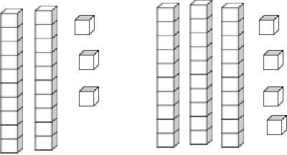
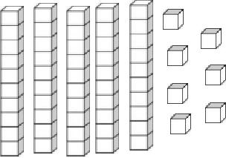

Counting tens and ones

Find the total number of blocks.
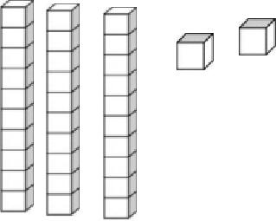

= 3 tens + 5 ones = ____35
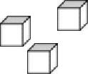

= __ tens + __ ones = ____

= __ tens + __ ones = ____
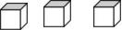

= __ tens + __ ones = ____

= __ tens + __ ones = ____

= __ tens + __ ones = ____

Counting tens and ones

Find the total number of blocks.
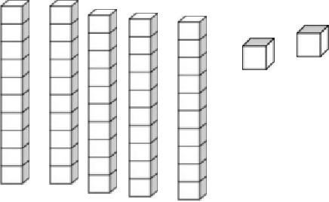

= __ tens + __ ones = ____

= __ tens + __ ones = ____

= __ tens + __ ones = ____

= __ tens + __ ones = ____
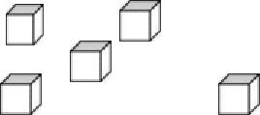

= __ tens + __ ones = ____

= __ tens + __ ones = ____

Counting tens and ones

Find the total number of blocks.
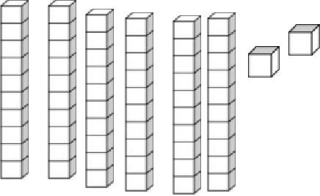

= __ tens + __ ones = ____

= __ tens + __ ones = ____

- __ tens + __ ones = ____

- __ tens + __ ones = ____
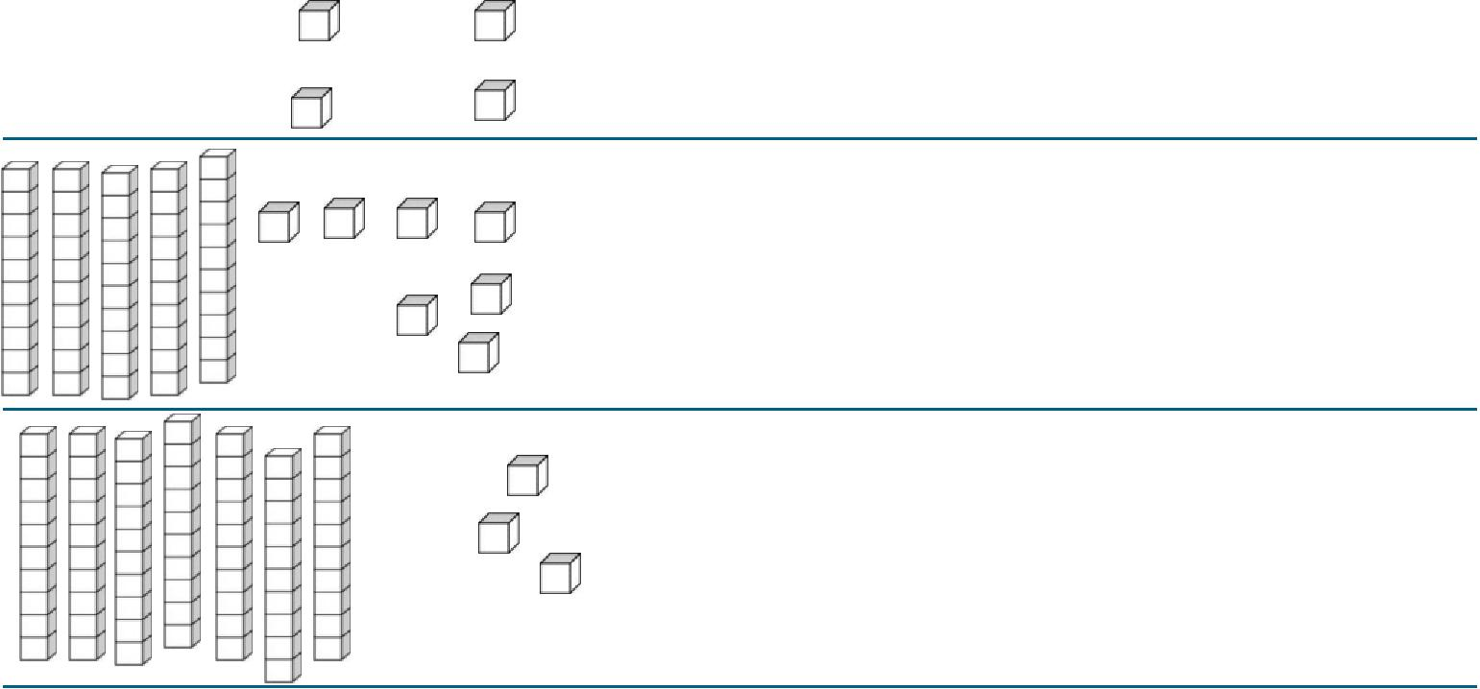

= __ tens + __ ones = ____
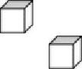

= __ tens + __ ones = ____
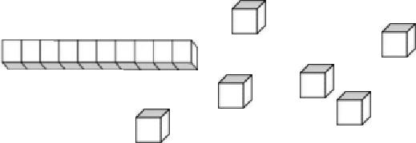

Counting tens and ones

Find the total number of blocks.
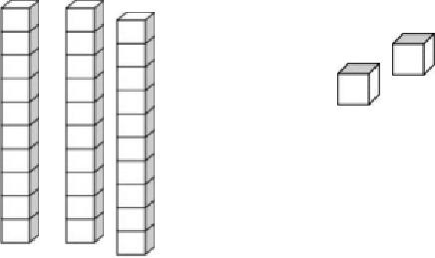

= __ tens + __ ones = ____

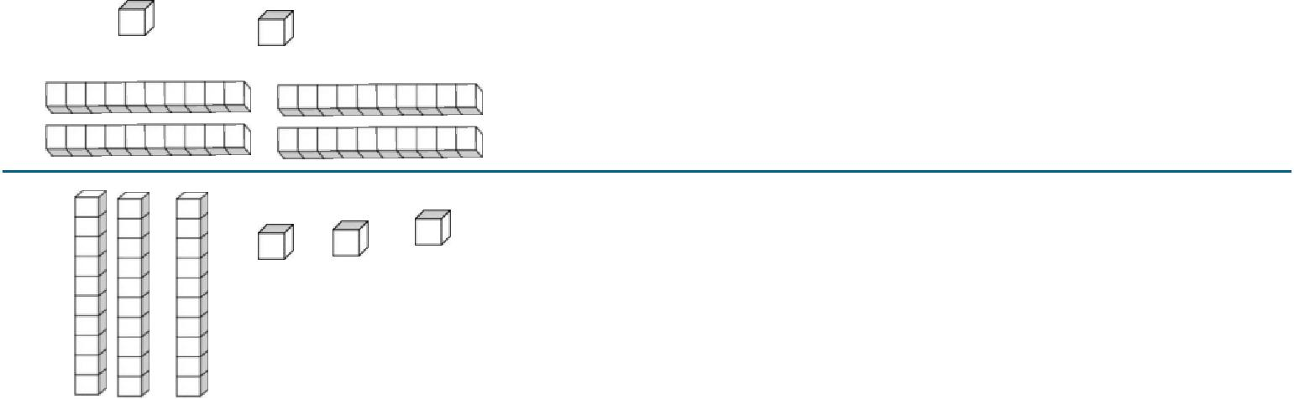
= __ tens + __ ones = ____

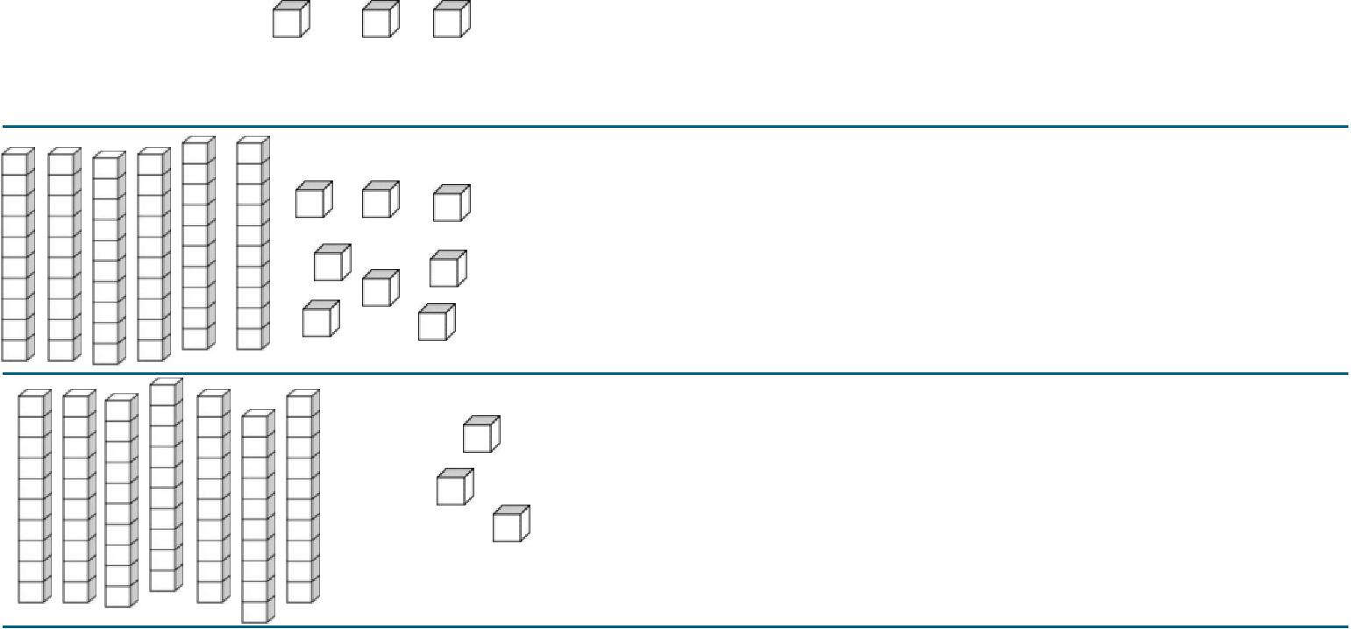
- __ tens + __ ones = ____

- __ tens + __ ones = ____
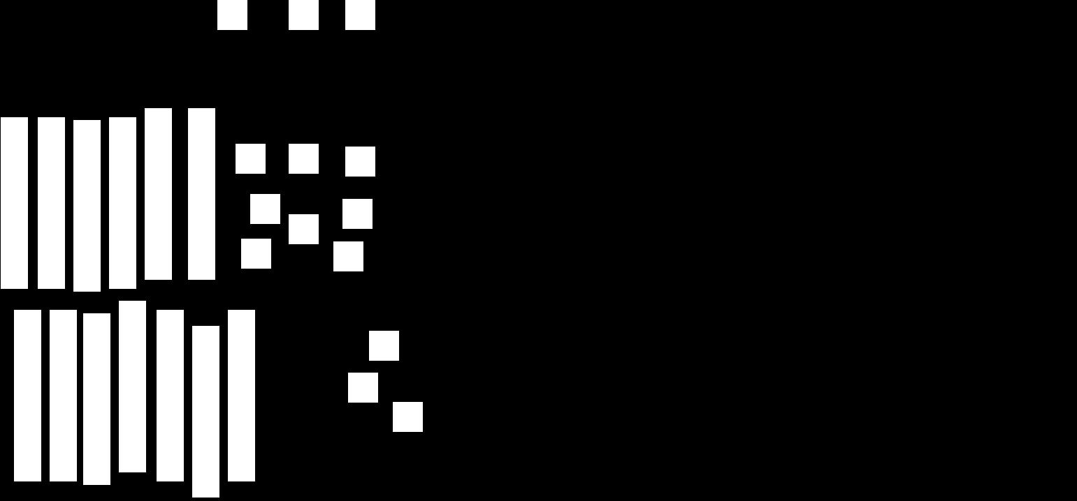

= __ tens + __ ones = ____
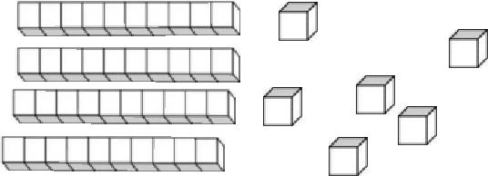

= __ tens + __ ones = ____
Counting tens and ones
Grade 1 Base Ten Blocks Worksheet

Find the total number of blocks.
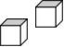
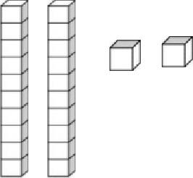

= __ tens + __ ones = ____

= __ tens + __ ones = ____
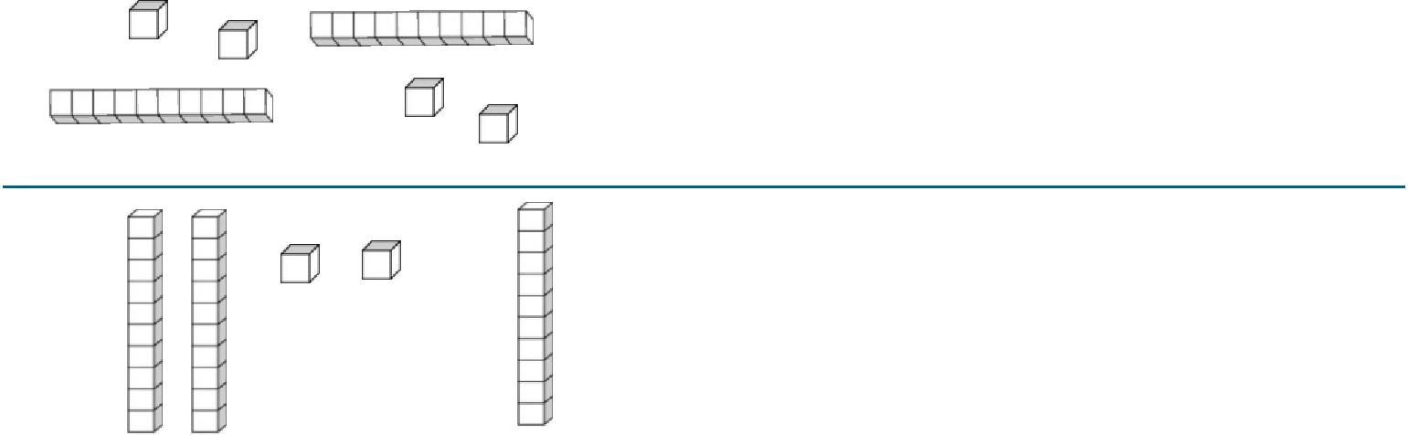

- __ tens + __ ones = ____

- __ tens + __ ones = ____

= __ tens + __ ones = ____

= __ tens + __ ones = ____
Counting tens and ones
Find the total number of blocks.
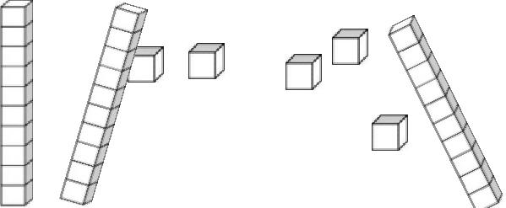

= __ tens + __ ones = ____

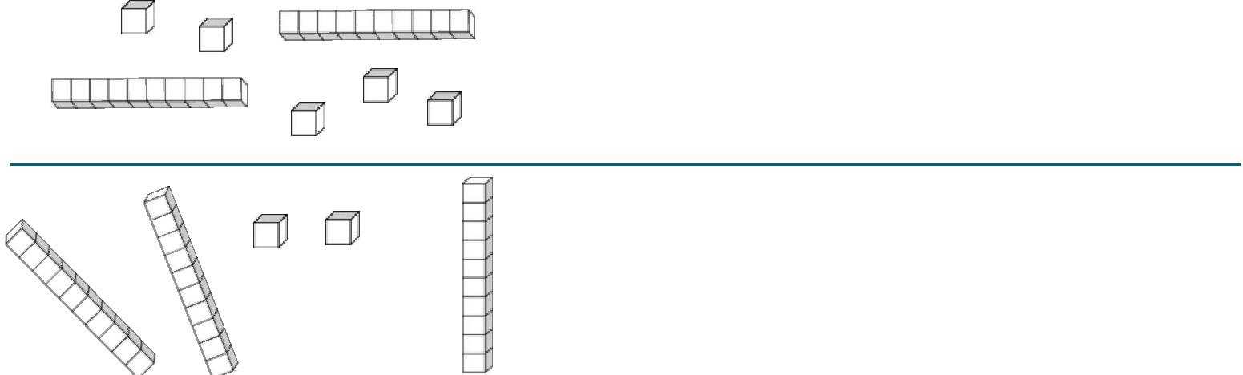
= __ tens + __ ones = ____

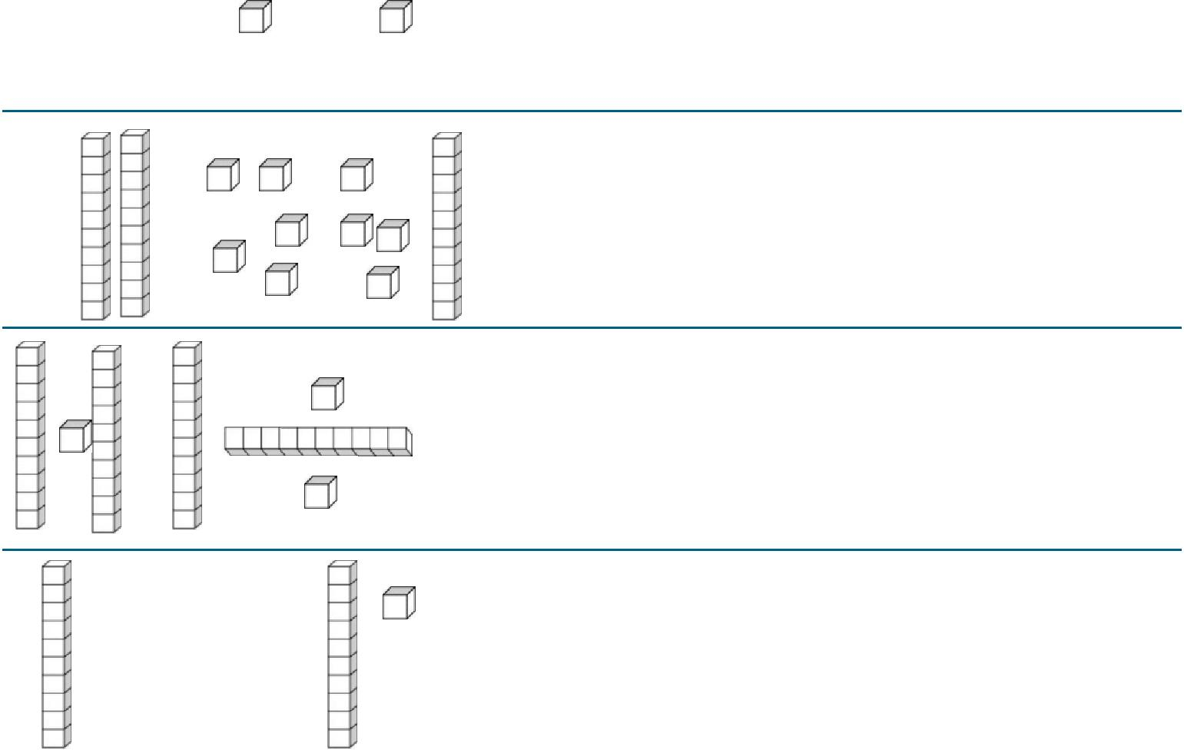
- __ tens + __ ones = ____

- __ tens + __ ones = ____

- __ tens + __ ones = ____

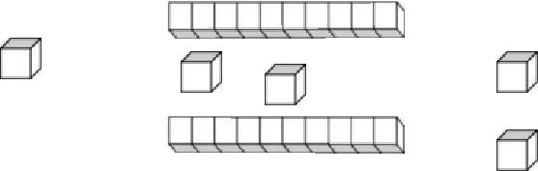

= __ tens + __ ones = ____
Creating groups of 10

Draw loops around sets of 10 blocks. Redraw the blocks as sets of ten.

Write the number.
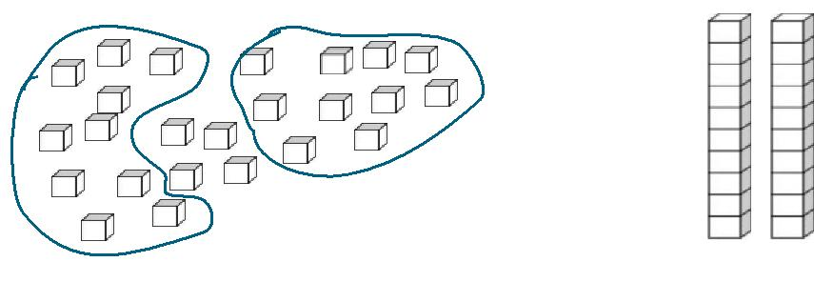
= | = 24

= =
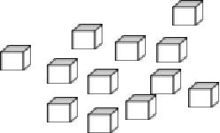
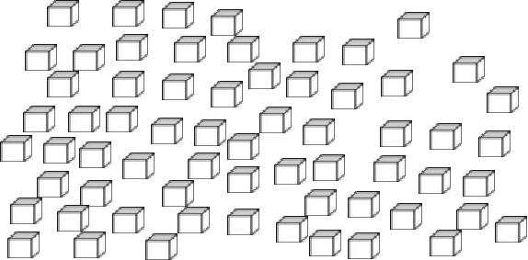

= =
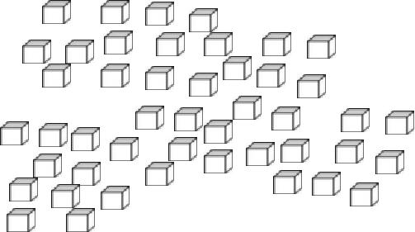

= =

= =

Creating groups of 10

Draw loops around sets of 10 blocks. Redraw the blocks as sets of ten.

Write the number.
= | = 24

= =
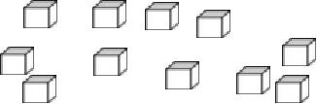

= =
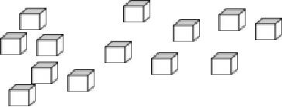
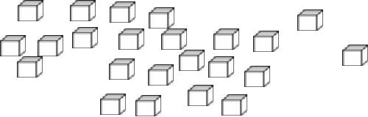

= =
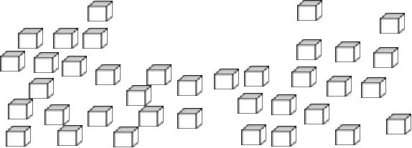

= =
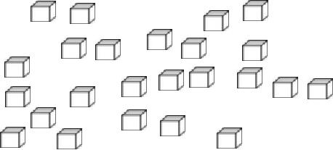

Creating groups of 10

Draw loops around sets of 10 blocks. Redraw the blocks as sets of ten.

Write the number.
= | = 24
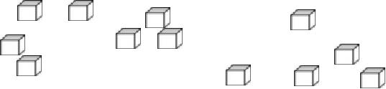

= =
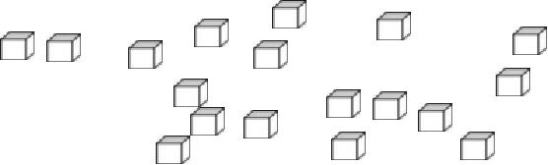

= =
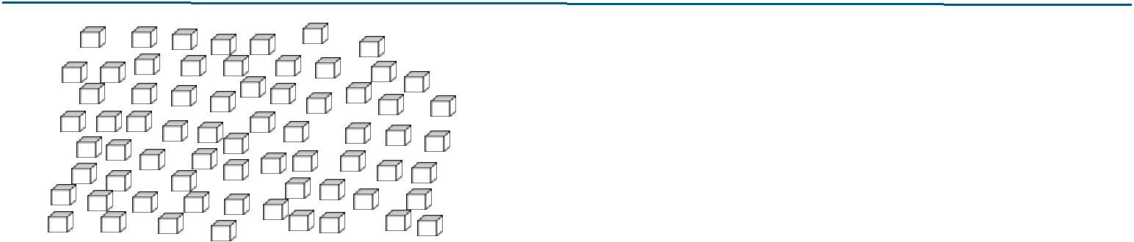

= =

= =
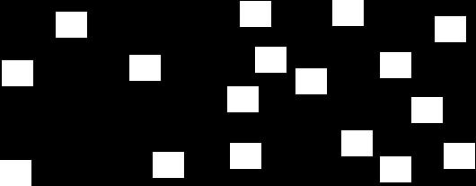
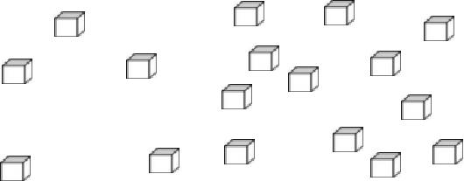

Creating groups of 10

Draw loops around sets of 10 blocks. Redraw the blocks as sets of ten.

Write the number.
= | = 24
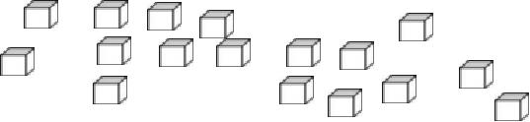

= =
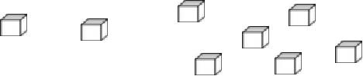
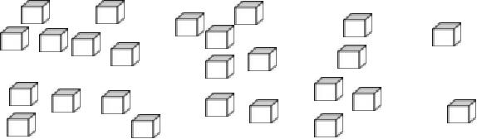

= =
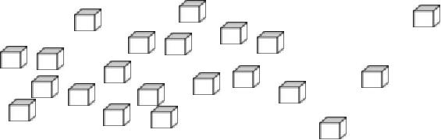
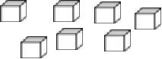

= =
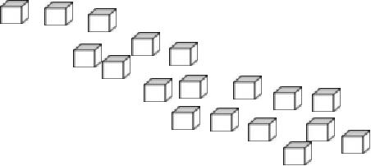
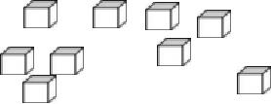

= =
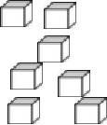

Creating groups of 10
Draw loops around sets of 10 blocks. Redraw the blocks as sets of ten.

Write the number.
= | = 24

= =

= =
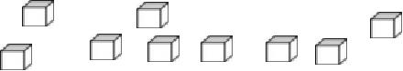

= =
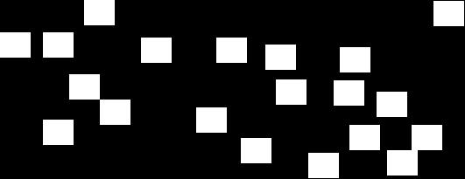
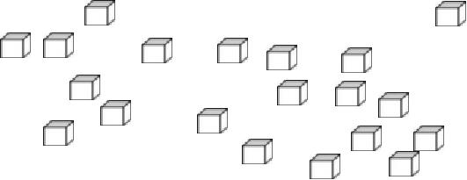
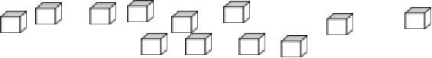

= =
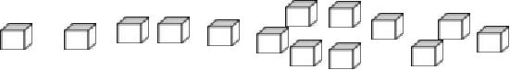

Breaking a number into tens and ones
Draw rods (tens) and blocks (ones) to represent the numbers shown.

34 = | 14 =
12 = | 60 =
7 = | 31 =
27 = | 19 =
22 = | 44 =
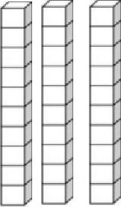

Breaking a number into tens and ones
Draw rods (tens) and blocks (ones) to represent the numbers shown.

34 = | 81 =
16 = | 33 =
20 = | 31 =
22 = | 3 =
62 = | 26 =

Breaking a number into tens and ones
Draw rods (tens) and blocks (ones) to represent the numbers shown.

34 = | 15 =
15 = | 51 =
43 = | 34 =
50 = | 30 =
12 = | 22 =

Breaking a number into tens and ones
Draw rods (tens) and blocks (ones) to represent the numbers shown.

34 = | 10 =
11 = | 12 =
20 = | 30 =
42 = | 52 =
36 = | 63 =

Breaking a number into tens and ones
Draw rods (tens) and blocks (ones) to represent the numbers shown.

34 = | 26 =
53 = | 27 =
17 = | 15 =
45 = | 32 =
30 = | 21 =

Identifying Place Value C1

Determine the place value of the underlined digit.

1) | 4 = |  | 2) |  | 69 =
3) | 79 = |  |  | 4) | 6 =
5) | 81 = |  |  | 6) | 3 =
7) | 7 = |  |  | 8) | 60 =
9) | 5 = |  |  | 10) | 8 =
11) | 40 = |  |  | 12) | 38 =
13) | 72 = |  |  | 14) | 64 =
15) | 61 = |  |  | 16) | 91 =
17) | 30 = |  |  | 18) | 56 =
19) | 58 = |  |  | 20) | 18 =

Identifying Place Value C2

Determine the place value of the underlined digit.

1) | 84 = |  | 2) |  | 28 =
3) | 24 = |  |  | 4) | 2 =
5) | 85 = |  |  | 6) | 4 =
7) | 43 = |  |  | 8) | 7 =
9) | 1 = |  |  | 10) | 70 =
11) | 37 = |  | 12) |  | 17 =
13) | 40 = |  |  | 14) | 29 =
15) | 9 = |  |  | 16) | 6 =
17) | 5 = |  |  | 18) | 44 =
19) | 60 = |  |  | 20) | 62 =

Identifying Place Value C3

Determine the place value of the underlined digit.

1) | 84 = |  | 2) |  | 48 =
3) | 44 = |  |  | 4) | 9 =
5) | 4 = |  |  | 6) | 7 =
7) | 15 = |  | 8) |  | 98 =
9) | 99 = |  |  | 10) | 77 =
11) | 3 = |  |  | 12) | 49 =
13) | 63 = |  | 14) |  | 8 =
15) | 6 = |  |  | 16) | 81 =
17) | 2 = |  |  | 18) | 30 =
19) | 80 = |  |  | 20) | 76 =

Identifying Place Value C4

Determine the place value of the underlined digit.

1) | 60 = | 2) |  | 4 =
3) | 6 = |  | 4) | 2 =
5) | 84 = | 6) |  | 79 =
7) | 68 = |  | 8) | 3 =
9) | 29 = |  | 10) | 49 =
11) | 46 = |  | 12) | 48 =
13) | 64 = |  | 14) | 41 =
15) | 89 = |  | 16) | 14 =
17) | 5 = |  | 18) | 7 =
19) | 57 = |  | 20) | 1 =

Identifying Place Value C5

Determine the place value of the underlined digit.

1) | 83 = |  | 2) |  | 2 =
3) | 4 = |  |  | 4) | 34 =
5) | 16 = |  |  | 6) | 55 =
7) | 14 = |  |  | 8) | 22 =
9) | 1 = |  |  | 10) | 3 =
11) | 89 = |  |  | 12) | 66 =
13) | 58 = |  |  | 14) | 51 =
15) | 8 = |  |  | 16) | 61 =
17) | 9 = |  |  | 18) | 45 =
19) | 25 = |  |  | 20) | 7 =

Identifying Place Value C6

Determine the place value of the underlined digit.

1) | 64 = |  | 2) |  | 95 =
3) | 5 = |  |  | 4) | 10 =
5) | 21 = |  |  | 6) | 18 =
7) | 82 = |  |  | 8) | 4 =
9) | 45 = |  |  | 10) | 2 =
11) | 73 = |  |  | 12) | 8 =
13) | 88 = |  |  | 14) | 6 =
15) | 66 = |  |  | 16) | 38 =
17) | 3 = |  |  | 18) | 72 =
19) | 7 = |  |  | 20) | 92 =

Place Value

Complete:

 |  | tens and |  | ones | = | 37
 |  |  |  | ones | = | 43
 |  | tens and
 |  |  |  | ones | = | 81
 |  | tens and
 |  |  |  | ones | = | 72
 |  | tens and
 |  |  |  | ones | = | 44
 |  | tens and
 |  |  |  | ones | = | 56
 |  | tens and
 |  |  |  | ones | = | 87
 |  | tens and
 |  |  |  | ones | = | 10
 |  | tens and
 |  |  |  | ones | = | 24
 |  | tens and

Place Value

Complete:

 |  | tens and |  | ones | = | 76
 |  |  |  | ones | = | 12
 |  | tens and
 |  |  |  | ones | = | 50
 |  | tens and
 |  |  |  | ones | = | 52
 |  | tens and
 |  |  |  | ones | = | 65
 |  | tens and
 |  |  |  | ones | = | 89
 |  | tens and
 |  |  |  | ones | = | 74
 |  | tens and
 |  |  |  | ones | = | 27
 |  | tens and
 |  |  |  | ones | = | 64
 |  | tens and
Place Value

Complete:

 |  | tens and |  | ones | = | 41
 |  |  |  | ones | = | 17
 |  | tens and
 |  |  |  | ones | = | 55
 |  | tens and
 |  |  |  | ones | = | 83
 |  | tens and
 |  |  |  | ones | = | 39
 |  | tens and
 |  |  |  | ones | = | 62
 |  | tens and
 |  |  |  | ones | = | 28
 |  | tens and
 |  |  |  | ones | = | 73
 |  | tens and
 |  |  |  | ones | = | 95
 |  | tens and

Place Value

Complete:

 |  | tens and |  | ones | = | 53
 |  |  |  | ones | = | 78
 |  | tens and
 |  |  |  | ones | = | 92
 |  | tens and
 |  |  |  | ones | = | 60
 |  | tens and
 |  |  |  | ones | = | 17
 |  | tens and
 |  |  |  | ones | = | 21
 |  | tens and
 |  |  |  | ones | = | 36
 |  | tens and
 |  |  |  | ones | = | 46
 |  | tens and
 |  |  |  | ones | = | 84
 |  | tens and

Place Value

 |  | tens and |  | ones | = | 67
 |  |  |  | ones | = | 93
 |  | tens and
 |  |  |  | ones | = | 14
 |  | tens and
 |  |  |  | ones | = | 71
 |  | tens and
 |  |  |  | ones | = | 50
 |  | tens and
 |  |  |  | ones | = | 48
 |  | tens and
 |  |  |  | ones | = | 26
 |  | tens and
 |  |  |  | ones | = | 85
 |  | tens and
 |  |  |  | ones | = | 32
 |  | tens and

Fill in the correct tens and ones for the given numbers.

 |  | tens and |  | ones | = | 80
 |  |  |  | ones | = | 11
 |  | tens and
 |  |  |  | ones | = | 23
 |  | tens and
 |  |  |  | ones | = | 75
 |  | tens and
 |  |  |  | ones | = | 98
 |  | tens and
 |  |  |  | ones | = | 59
 |  | tens and
 |  |  |  | ones | = | 61
 |  | tens and
 |  |  |  | ones | = | 33
 |  | tens and
 |  |  |  | ones | = | 47
 |  | tens and
Place Value

Fill in the correct tens and ones for the given numbers.

= 5 tens and 8 ones

= 6 tens and 6 ones

= 1 ten and 9 ones

= 3 tens and 7 ones

= 4 tens and 3 ones

= 8 tens and 7 ones

= 9 tens and 4 ones

= 2 tens and 6 ones

